BLACK

CITY

ELIZABETH RICHARDS

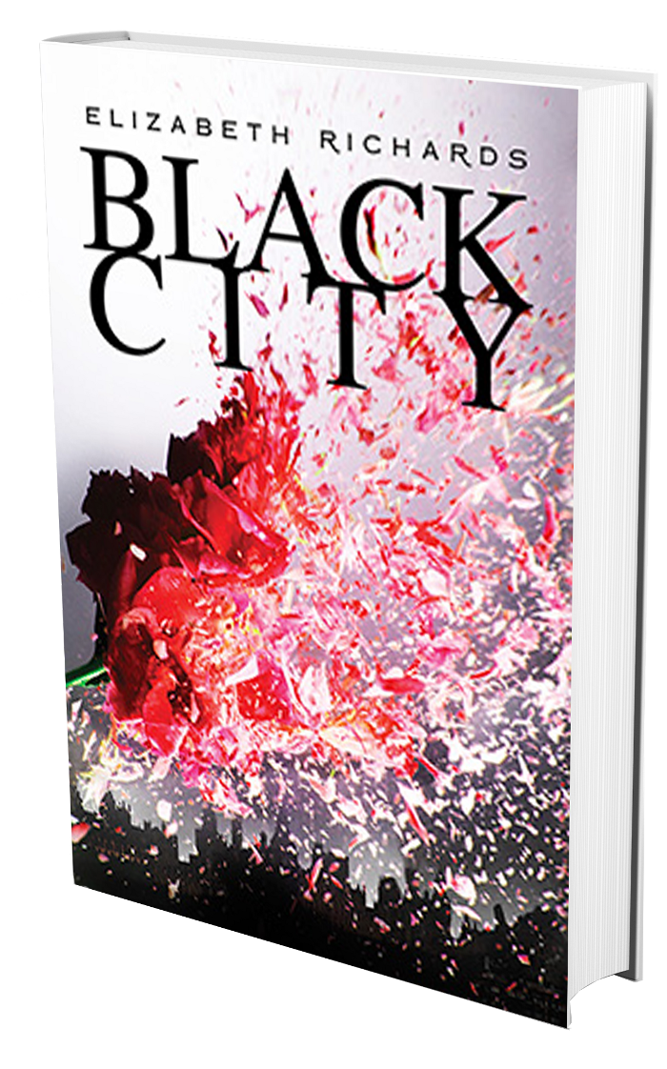

***The boundary walls couldn’t keep them apart***

***“A lusty romance in a world gone awry”***

The Bulletin of the Center for Children's Books on BLACK CITY

CITY

BLACK

***Shivers run through***

***my body , rushing toward a single point in my chest. There’s a spark of electricity and then:***

***a flutter.***

Natalie, a human and the daughter of a government official, is still

reeling from her father’s

murder by a crazed Dark-

ling, so how can she now

be falling for Ash, a brood-

ing half-blood Darkling

boy?

Despite being half-hum-

an, Ash is scorned every-

where he goes. The Sentry

have banished all Darklings to the wrong side of the ghetto wall and would love

nothing more than to have them totally era-

dicated from United Sentry

States. Though he tries to deny how he how he feels about Natalie, as

it could be a danger to them

both, Ash is finding it hard to

stay away…

In the aftermath of a terri-

ble, bloody war in the still-

smoldering Black City, Nat-

alie and Ash do the unthink-able—they fall in love.

***A dark and tender post-apocalyptic love story set in the aftermath of a bloody war.***

C:\Users\Liz\AppData\Local\Microsoft\Windows\Temporary Internet Files\Content.IE5\PGK3AS9L\MC900026835[1].wmf

**READ AN EXCERPT**

Footsteps approach the bridge, and my stomach leaps into my throat. Sebastian and Kurt have returned.

“Let’s get back to headquarters,” Sebastian says to Kurt as he climbs into the truck. “Natalie’s probably gone home.”

“She better have,” Kurt mutters. “The Emissary will have my head if her daughter gets chomped by a rogue Darkling. Bloody nippers, I don’t know how they keep getting over the wall.”

The Darkling boy’s eyes narrow. “You’re the Emissary’s daughter?”

Fear tiptoes down my spine. I gulp, realizing the danger I’m in.

“I don’t want any trouble,” I say.

“Too late for that, blondie.” The corners of his mouth curl up to reveal his fangs.

I hurriedly edge away from him. My back slams into the cold stone wall. I’m trapped.

We eye each other steadily, waiting to see what’s going to happen next. There are only two options: he lets me go and trusts I won’t report him. Or he kills me.

My heart bangs against my chest. I hold my breath, waiting.

He snarls. “Tell anyone about me, and you’re dead.”

He gets to his feet, and in a flash, he’s gone.

*-from BLACK CITY, pages 8-9*

Dark Readers on BLACK CITY

Product details

ISBN: 978-0-399-15943-5

Hardback release: November 13, 2012

Paperback release: May 7, 2013

Press contact

Elyse Marshall

elyse.marshall@us.penguingroup.com

Agent contact

Ayesha Pande

ayesha@pandeliterary.com

212.283.5825

Kendare Blake, author of Anna Dress in Blood

Booklist on BLACK CITY

***“A world of darkness and death. The creatures are deadly. The humans brutal. Black City seethes.”***

***“Detailed postapocalyptic world building makes Richards’ series debut intriguing.”***

***“A bloody, gory, sexy, hellish Romeo and Juliet.”***

C:\Users\Liz\AppData\Local\Microsoft\Windows\Temporary Internet Files\Content.IE5\PGK3AS9L\MC900026835[1].wmf

About the author

Elizabeth Richards is an award-winning journalist,

who spent her early career reviewing videogames

before making the bold (or crazy) move into travel

writing, despite suffering from terrible travel sickness.

In her spare time, she ran a successful lifestyle web-

site aimed at teenage girls, where she got to inter-

view many of her favorite bands, go to gigs and

basically blag loads of free swag all in the name

of ‘research’.

Elizabeth lives in Buckinghamshire, England, with her husband. BLACK CITY is her

debut novel. The sequel, PHOENIX, is out on June 4, 2013.



USA Today on BLACK CITY

***“Fans of urban fantasy and forbidden romance will definitely want to pick this one up.”***

BLACK

CITY